Notes
Linear Regression:

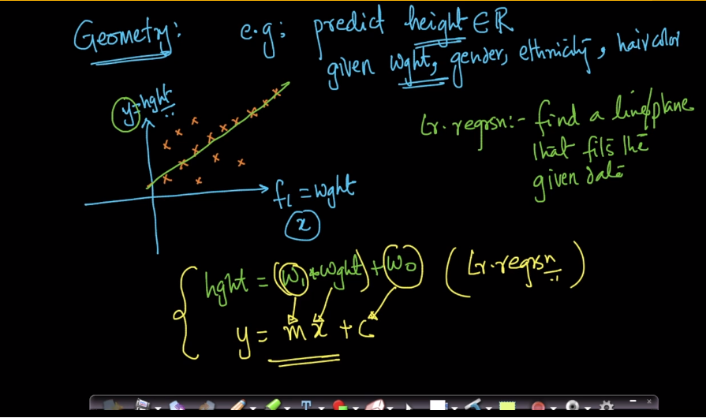
Linear regression in higher dimensional space has hyper plane to predict.

Linear regression that best fits a line to the given data.
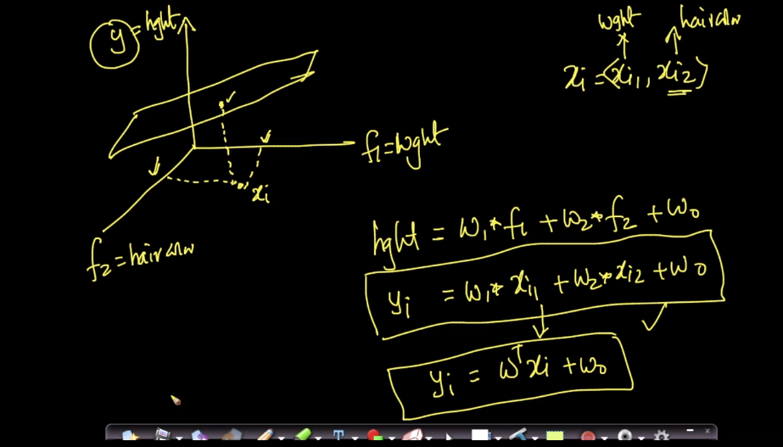
Error of the model:
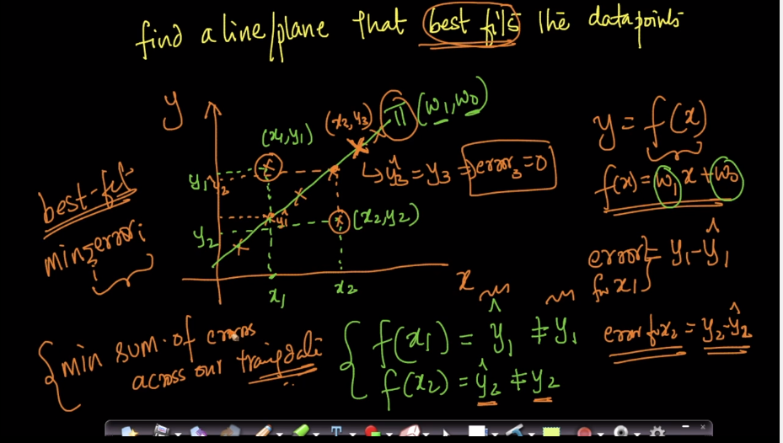
Mathematical formulation:

Error for the extreme points..
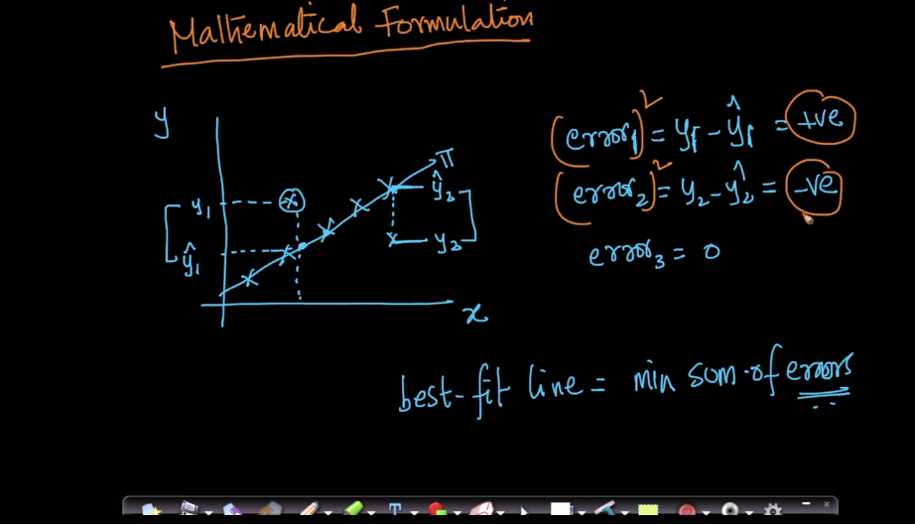

The mathematical formulation is to find the (W, W0) that minimize the difference between the actual and predicted value of y.
Liner regression is also referred to as OLS(Ordinary Least Squares).

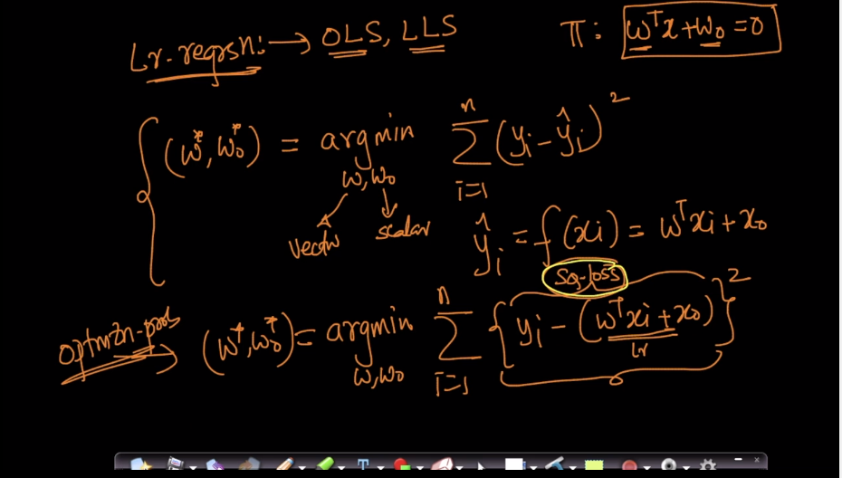
Same like we need to use Regularization to the Linear regression.
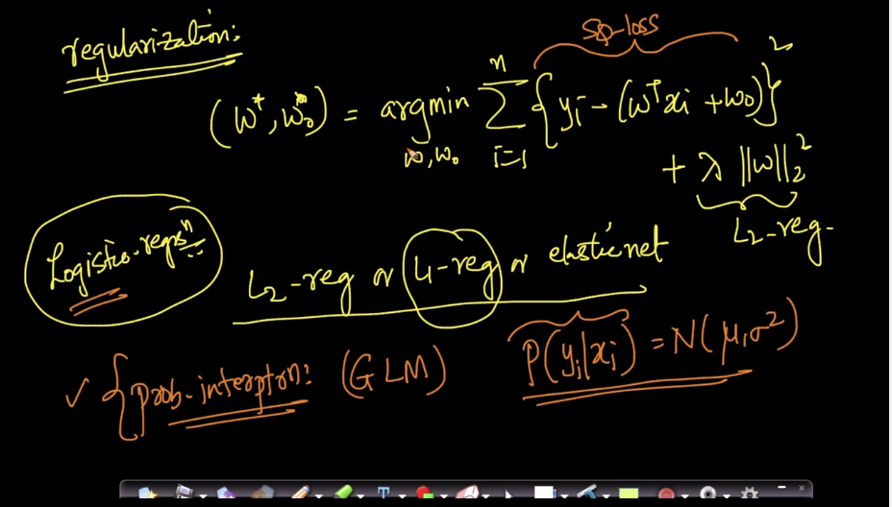
Loss minimization:

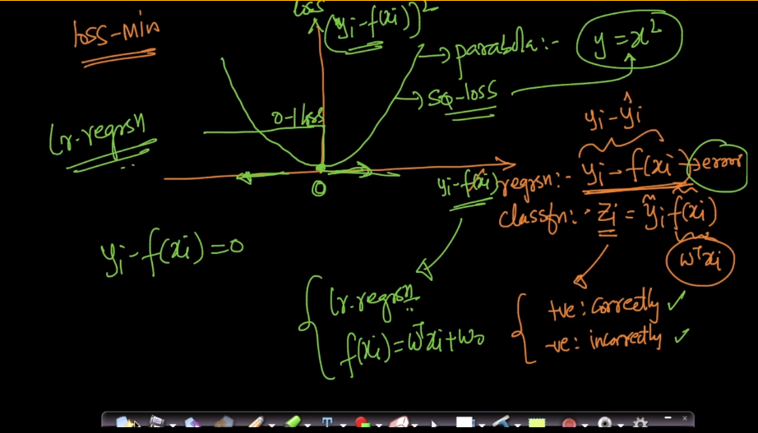
Using Loss minimization frame work, If we take SQ loss we get Linear regression, OLS, LLS.

Real world Cases:
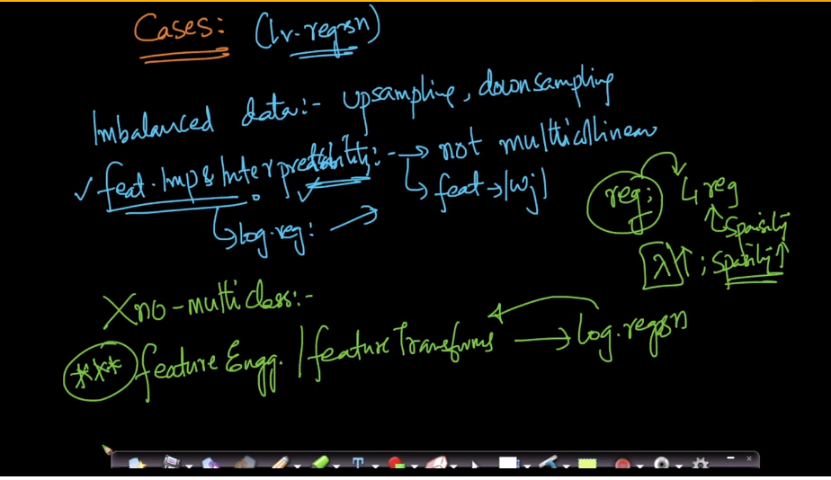
Outliers effect on the linear regression:

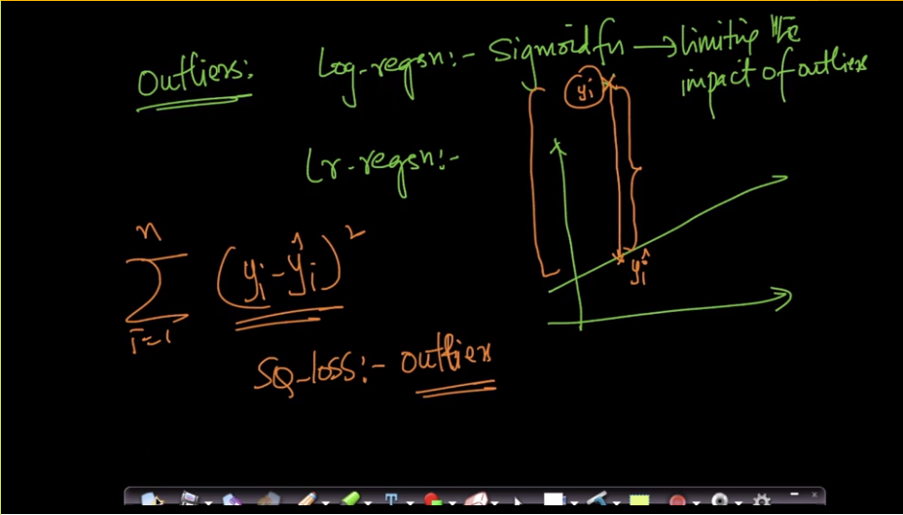
Outliers can mess up the Linear regression:

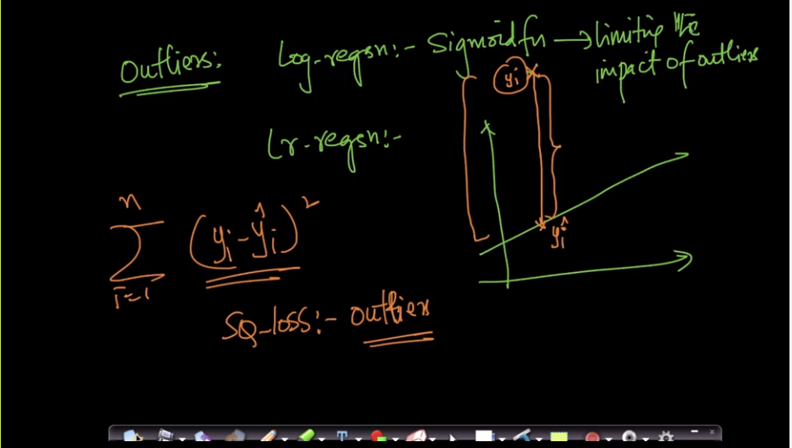

Using all of the train data we will find the W* and W0*
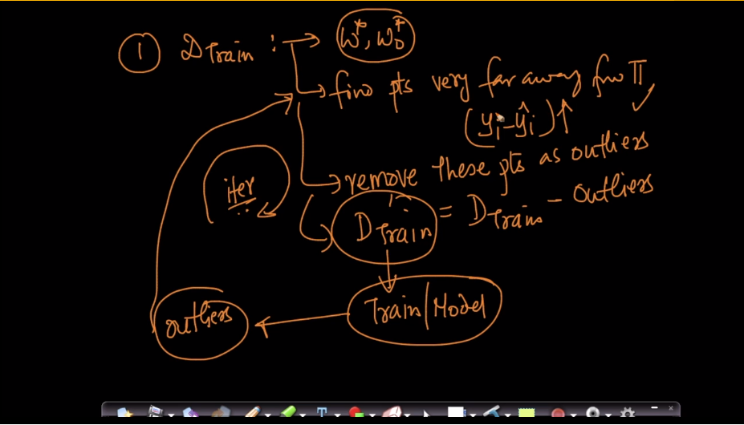
Iteratively remove the outliers from the data.

This is called RANSAC.

